🚨 SQL Hack Few People Know About
💨 Did you know you can create checkpoints within a transaction using SAVEPOINT? Instead of this (losing all work when something fails)
A SAVEPOINT allows you to create a point within a transaction that you can roll back to. A typical rollback undoes the entire transaction; a savepoint rollback only reverts the changes made after the savepoint was created.
SAVEPOINTs are like checkpoints in an oil pipeline system. If something goes wrong downstream, you can isolate the damage by reverting to the last safe checkpoint, without shutting down the entire pipeline.
The following code will rollback everything:
BEGIN;
INSERT INTO orders VALUES (1, 'Laptop');
INSERT INTO payments VALUES (1, 'FAILED');
-- Something goes wrong here
ROLLBACK; -- Kills BOTH the order AND Payment
If you throw in some SAVEPOINT, then you can rollback the transaction to the last savepoint:
BEGIN;
INSERT INTO orders VALUES (1, 'Laptop');
-- Create a savepoint
SAVEPOINT before_payment;
INSERT INTO payments VALUES (1, 'FAILED');
-- Payment failed! Roll back just the payment
ROLLBACK TO SAVEPOINT before_payment;
-- Trying alternative payment method
INSERT INTO payments VALUES (1, 'SUCCESS');
COMMIT;
🔑 SAVEPOINTS are lifesavers in situations where the cost of redoing the whole transaction is so high that you are better off just redoing part of the transaction. A great transaction management tool makes your workflow more flexible, especially in complex operations.
⚠️ SAVEPOINTs don’t stop the fire. They just make sure you don’t burn the whole house down.
Activate to view larger image,
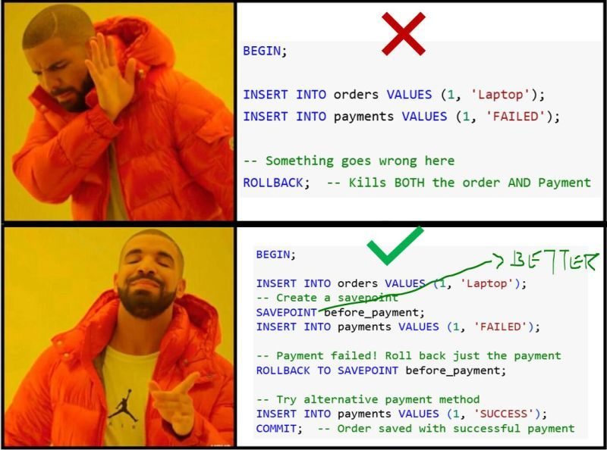

Give me 2 minutes...
...and I'll probably save you hours of writing SQL.
One thing I realized after working on production data pipelines is that the best SQL developers don't know hundreds of functions—they know the 20–30 commands that solve 90% of real-world problems.
Need to remove duplicates? → ROW_NUMBER()
Need to compare today's data with yesterday's? → LAG()
Need running totals? → SUM() OVER()
Need to upsert millions of records? → MERGE
Need to filter window function results? → QUALIFY
These aren't just interview questions—they're patterns you'll use repeatedly while building ETL pipelines, dashboards, and analytical models.
That's why I created this SQL one-liner cheat sheet.
No lengthy explanations.
No theory overload.
Just the commands you'll find yourself reaching for almost every day.
📌 Save this for your next SQL project.
📌𝗘𝗻𝗿𝗼𝗹𝗹 𝗻𝗼𝘄 𝗶𝗻 𝗼𝘂𝗿 𝟰𝘁𝗵 𝗗𝗮𝘁𝗮 𝗘𝗻𝗴𝗶𝗻𝗲𝗲𝗿𝗶𝗻𝗴 𝗖𝗼𝗵𝗼𝗿𝘁 𝗮𝗻𝗱 𝗸𝗶𝗰𝗸𝘀𝘁𝗮𝗿𝘁 𝘆𝗼𝘂𝗿 𝗗𝗮𝘁𝗮 𝗘𝗻𝗴𝗶𝗻𝗲𝗲𝗿𝗶𝗻𝗴 𝗷𝗼𝘂𝗿𝗻𝗲𝘆 - https://lnkd.in/gPiDZuyS
Activate to view larger image,
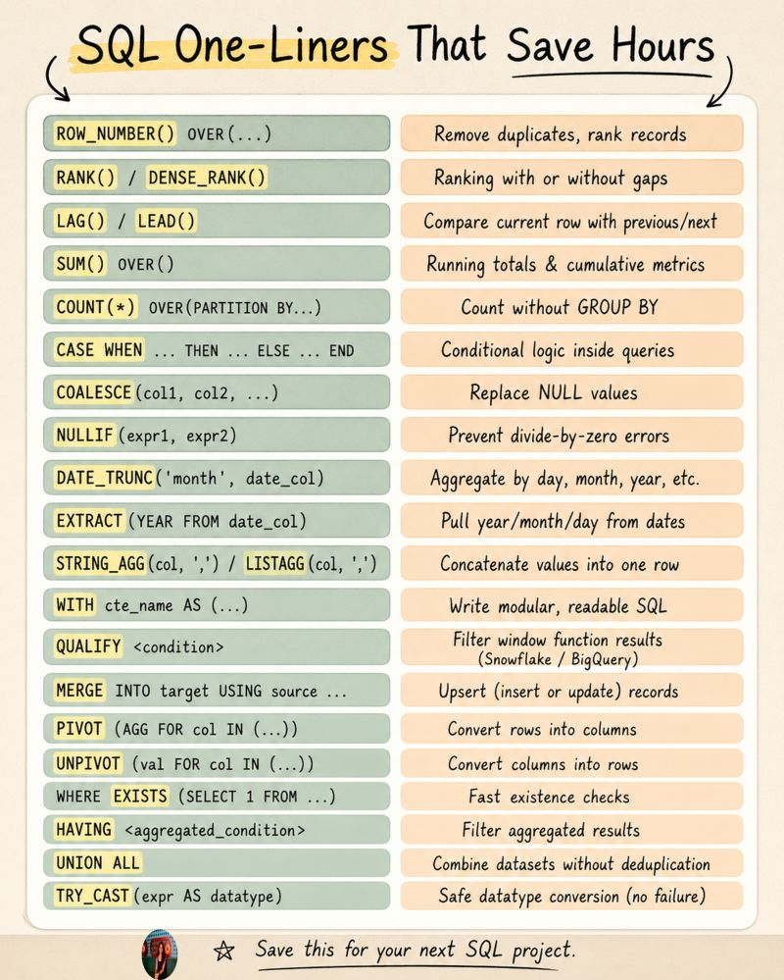

Courses teach you to query data. They don't teach you to read it.
Five concepts that come up constantly in real data jobs, and never once in a beginner course.
1. Granularity, "the grain"
Before you write a single query, ask what a row in this table actually means. One row per customer? One row per transaction? Get this wrong and your query runs fine, no errors, and the number is just quietly wrong.
2. NULL vs zero
NULL doesn't mean zero. It means unknown. SUM and COUNT both skip it entirely, so a revenue column full of NULLs isn't slightly off, it's silently excluding real rows from your total.
3. Window functions
ROW_NUMBER, RANK, LAG, LEAD. They let you calculate across rows, rank things, compare to the row before, without collapsing your data with a GROUP BY. Confusing at first, essential once it clicks.
4. Cardinality
How tables relate to each other, one customer to many orders, one product to many sales lines. Join two tables without knowing which way that relationship goes, and you don't get an error. You get row duplication, and every SUM after that is quietly inflated.
5. Correlation vs causation
Revenue went up 20% the month you launched a campaign. That doesn't mean the campaign caused it. Before you take credit, check what else happened that month.
The other five, statistical significance, cohort analysis, data freshness, OLTP vs OLAP, and warehouse vs lake vs mart, are in the full video.
Watch it here → https://lnkd.in/dhDBR-Uf
Activate to view larger image,
